**ENVIRONMENTAL SETUP IN LINUX(APACHE,MYSQL,PHP)**

1. **COMMANDS WHICH I USED FOR MY APACHE, MYSQL,PHP SETUP**

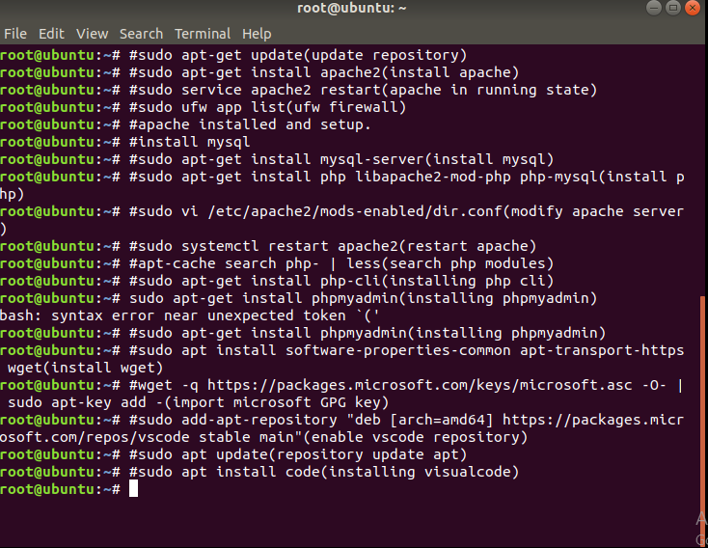

2) **THIS IS MY APACHE WELCOME SCREEN-**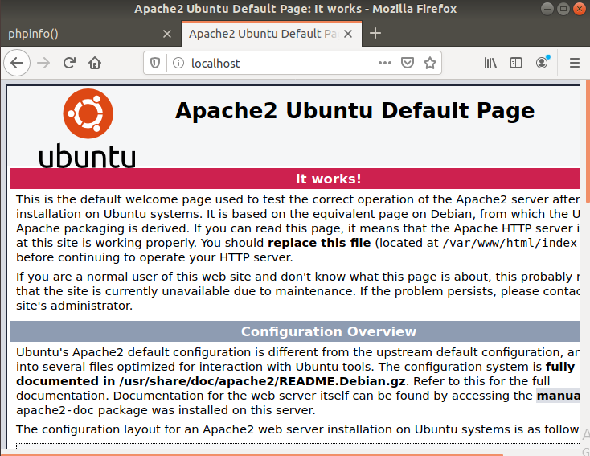

3) **THIS IS MY PHPMYINFO SCREEN**

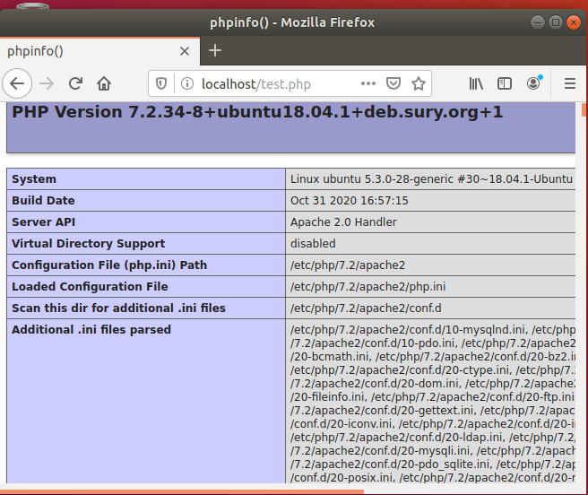

**4) THIS IS MY SQL CLI LOGIN SCREEN**-

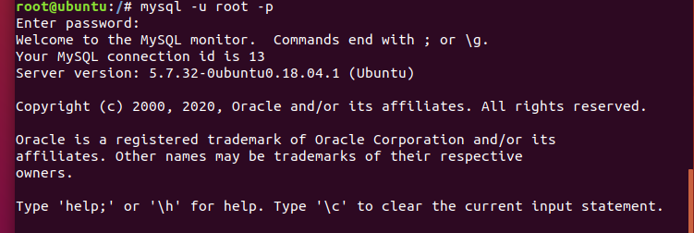

**THANKS.**